Step 1: create route with button click and write below code for delete MongoDB session.

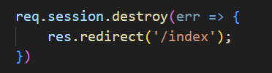

Above function delete stored session object from MongoDB.